JDK , JVM , JRE Architecture
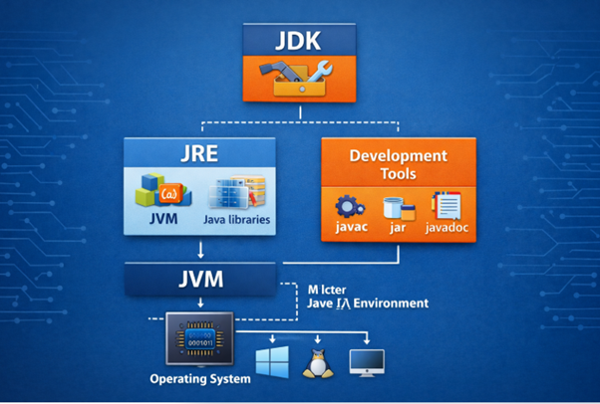

Java Architecture Overview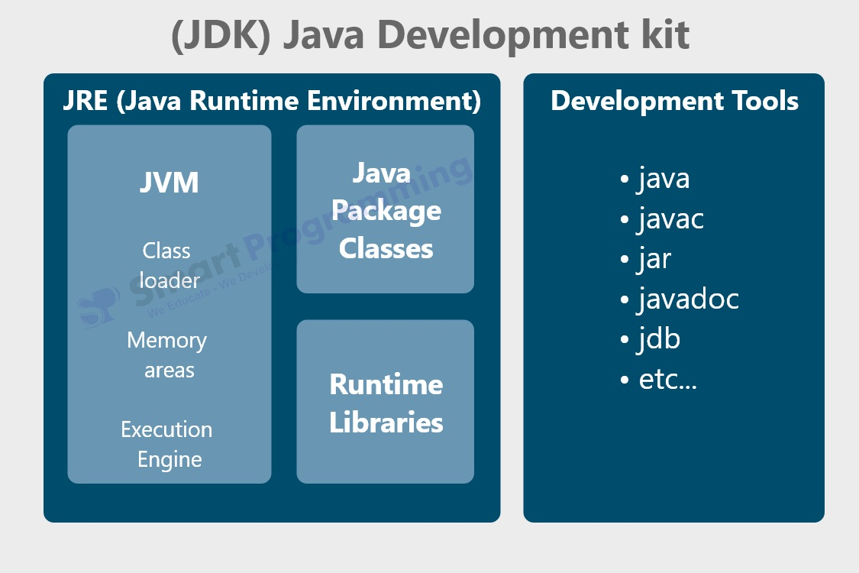
Relationship:
JDK
└── JRE
└── JVM
Or
JDK = JRE + Development Tools
JRE = JVM + Libraries

1️⃣ JVM (Java Virtual Machine)
The Java Virtual Machine (JVM) is the core component of Java technology.
It is a virtual computer that runs Java programs.
Instead of converting Java programs directly into machine code, Java converts them into bytecode, which is executed by the JVM.
Because every operating system has its own JVM implementation, the same Java program can run on Windows, Linux, and macOS.

Responsibilities of JVM
The JVM performs many important tasks:
• Loads Java class files into memory
• Verifies bytecode for security and correctness
• Converts bytecode into machine code
• Executes Java programs
• Manages memory allocation
• Performs garbage collection

Java Program Execution Process
Java Source Code (.java)
↓
Compiler
(javac)
↓
Bytecode (.class)
↓
JVM
↓
Machine Code
↓
Operating System
Steps explained:
- Developer writes Java code in .java file
- The javac compiler converts it to bytecode (.class)
- JVM loads the bytecode
- JVM converts bytecode into machine code
- Program executes on the operating system

JVM Internal Architecture :
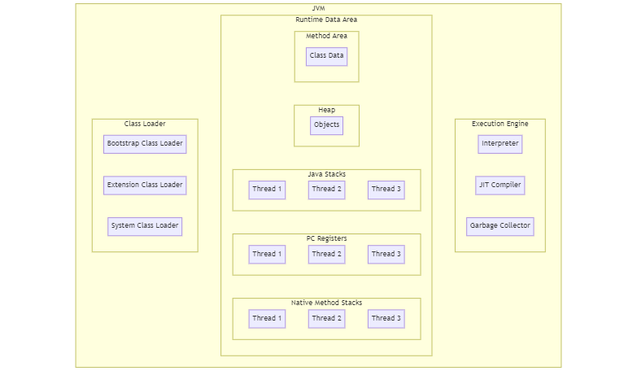
1. Class Loader Subsystem
The Class Loader loads .class files into memory.
It performs three main steps:
Loading
The class loader loads Java class files into JVM memory.
Example:
Test.class
Linking
Linking includes:
1️⃣ Verification – checks if bytecode is valid
2️⃣ Preparation – allocates memory for static variables
3️⃣ Resolution – converts symbolic references to direct references
Initialization
Static variables and static blocks are initialized.

2. Runtime Data Areas
These areas manage memory during program execution.

Heap
Heap memory stores:
• Objects
• Instance variables
Example:
Student s = new Student();
The object Student is stored in heap memory.
Heap is shared among all threads.

Stack
Stack memory stores:
• Method calls
• Local variables
Example:
int a = 10;
Stored inside the stack frame.
Each thread has its own stack.

Method Area
Stores:
• Class structure
• Static variables
• Method code
• Constant pool

PC Register
The Program Counter Register stores the address of the current instruction being executed.
Each thread has its own PC register.

Native Method Stack
Used for executing native methods written in languages like C or C++.
Example:
JNI (Java Native Interface)

3️⃣ Execution Engine
The execution engine runs the bytecode.
It consists of:

Interpreter
The interpreter reads bytecode line by line and executes it.
Advantage:
• Simple execution
Disadvantage:
• Slower performance

JIT Compiler (Just-In-Time Compiler)
To improve performance, JVM uses JIT Compiler.
Instead of interpreting repeatedly, JIT converts frequently executed bytecode into native machine code.
Benefits:
• Faster execution
• Optimized performance

4️⃣ Garbage Collector (GC)
Java automatically manages memory using Garbage Collection.
When an object is no longer referenced, the garbage collector removes it from memory.
Example:
Student s = new Student();
s = null;
Now the object becomes eligible for garbage collection.
Advantages:
• Prevents memory leaks
• Automatic memory management
• Improves application stability

2️⃣ JRE (Java Runtime Environment)
The Java Runtime Environment (JRE) provides everything needed to run Java programs.
If a user only wants to run Java applications, they only need JRE.

Components of JRE
JRE
├── JVM
├── Java Class Libraries
└── Supporting Files

Java Class Libraries
These are prewritten classes that developers use.
Common libraries include:
java.lang
java.util
java.io
java.net
java.sql
Example:
System.out.println("Hello Java");
System and PrintStream classes come from java.lang library.

Role of JRE
JRE ensures that Java applications run consistently across different systems.
This is what makes Java platform independent.
3️⃣ JDK (Java Development Kit)
The JDK is the complete toolkit used by developers to build Java applications.
It includes:
• JRE
• Development tools
• Compiler
• Debugging utilities

JDK Structure
JDK
├── JRE
│ ├── JVM
│ └── Libraries
│
└── Development Tools

Important JDK Tools
javac
Java compiler that converts .java files into .class.
Example:
javac Hello.java

java
Used to run the compiled program.
java Hello

jar
Packages multiple files into a Java Archive file.
Example:
jar cvf app.jar Test.class

javadoc
Generates documentation from Java source code.

jdb
Java debugger used to detect and fix errors.

Complete Java Development Flow
Write Code
↓
Save as .java file
↓
Compile using javac
↓
Generate .class bytecode
↓
JVM loads bytecode
↓
Execution Engine runs code
↓
Program runs on OS

Difference Between JDK, JRE, and JVM
Component | Description
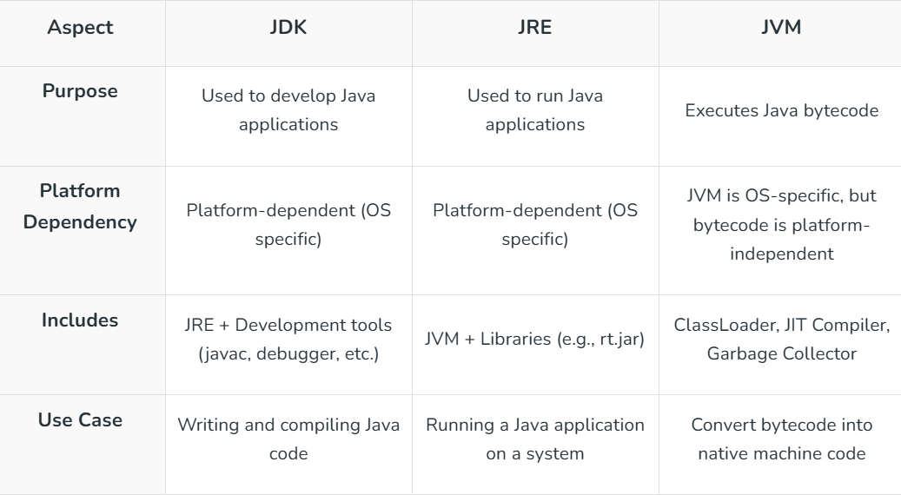
Simple Way to Remember
JDK → Used to DEVELOP Java programs
JRE → Used to RUN Java programs
JVM → Used to EXECUTE Java bytecode
Or
JDK = JRE + Tools
JRE = JVM + Libraries

Key Insight
Java programs do not run directly on the operating system.
Instead:
Java Code → Bytecode → JVM → Machine Code
This architecture is what makes Java:
• Platform Independent
• Secure
• Portable

